AWS Task-2
Task Description:
Set up a VPC with an Internet gateway, create a public subnet with 256 IP addresses, a private subnet with 256 IP addresses, make a route table connecting the Internet gateway and the subnets, and launch a Linux EC2 instance by using the above VPC and public subnet.
1.VPC:
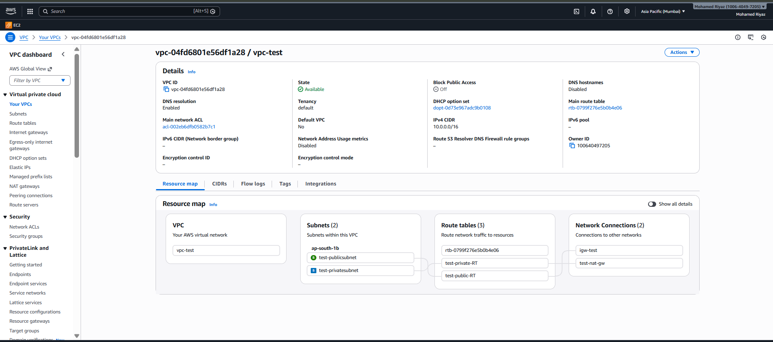
Public Subnet:
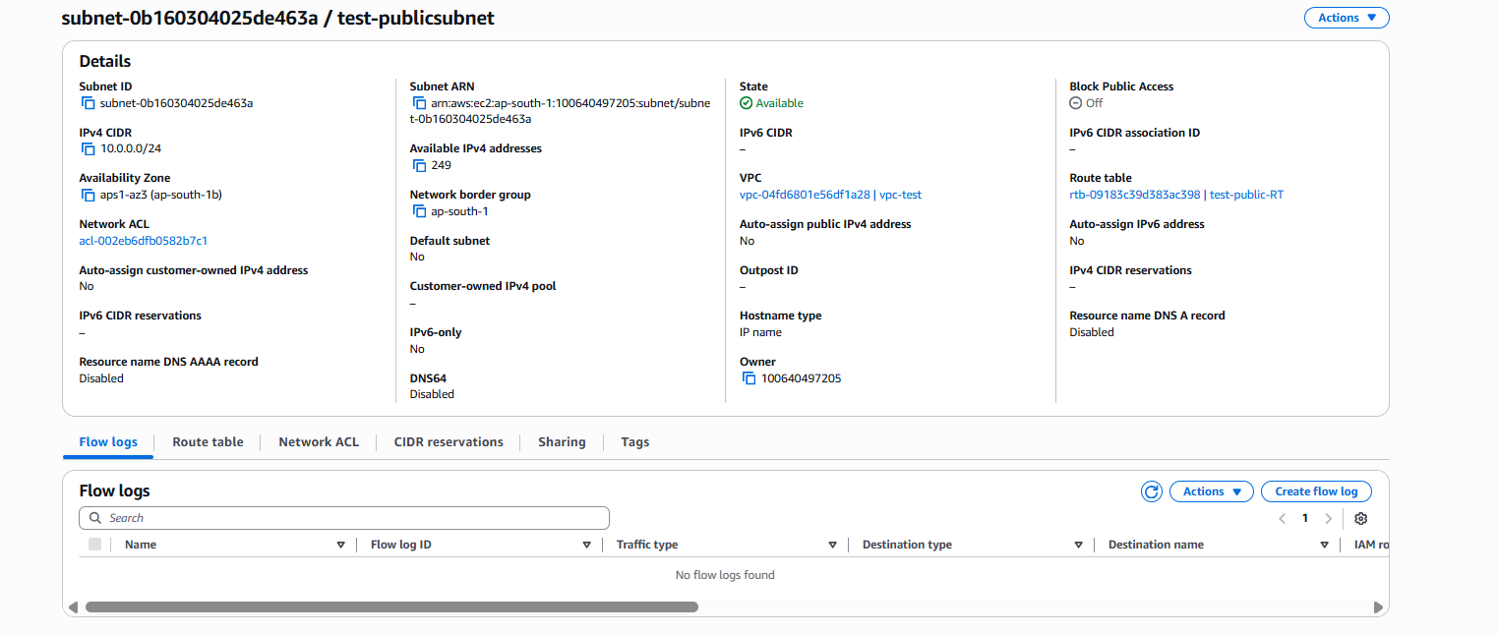
Route Table:
Public RT
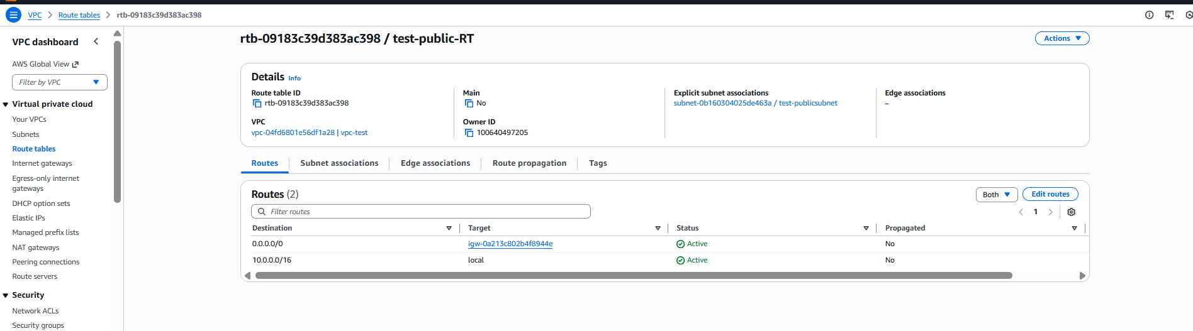
IGW with VPC:
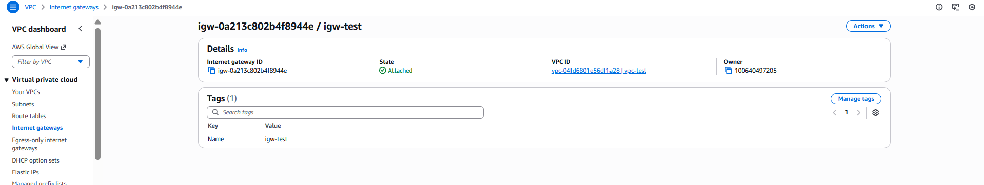
EC2 Instances: Public with VPC Config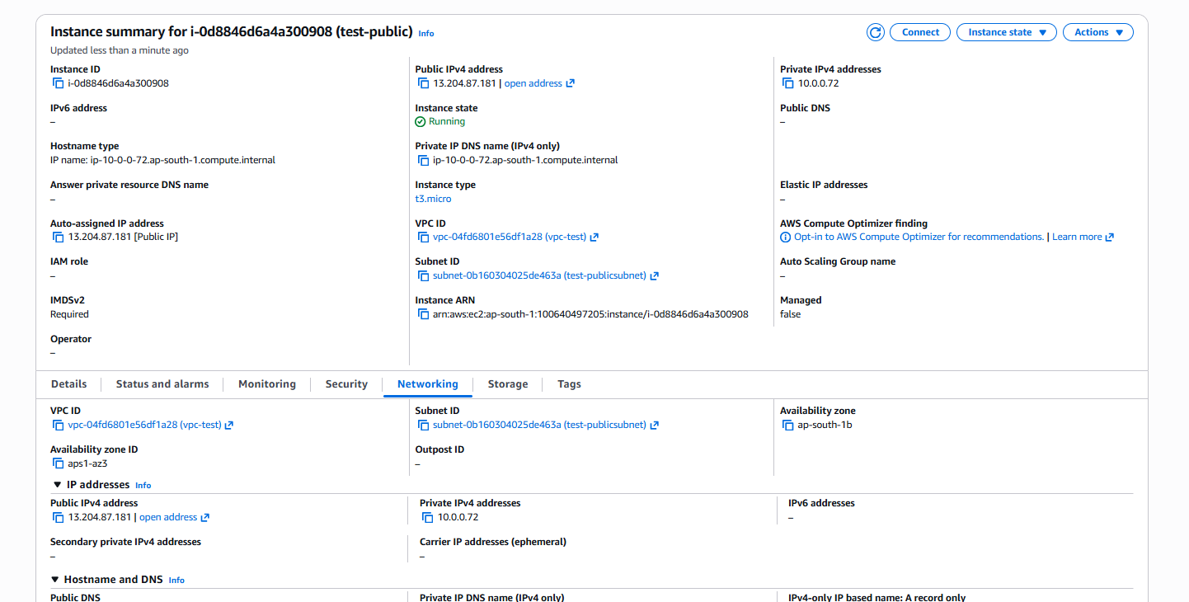
NAT Gateway:
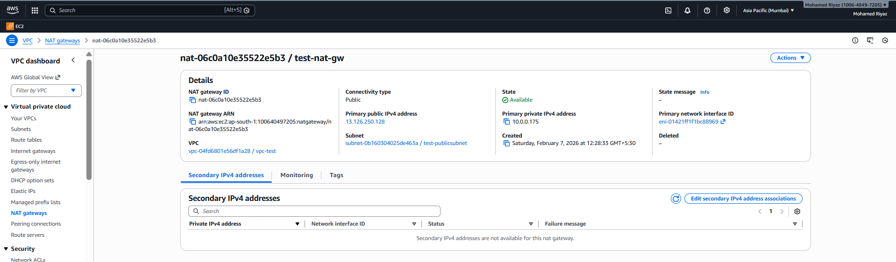
EC2 Instances: Private subnet with VPC Config:
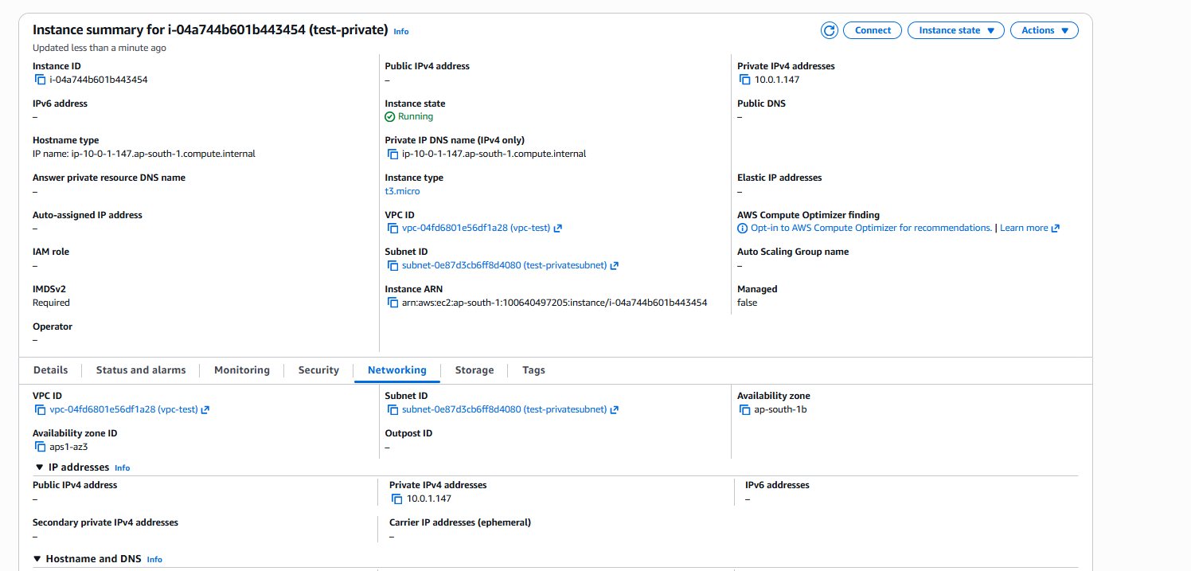
Launching EC2 public :
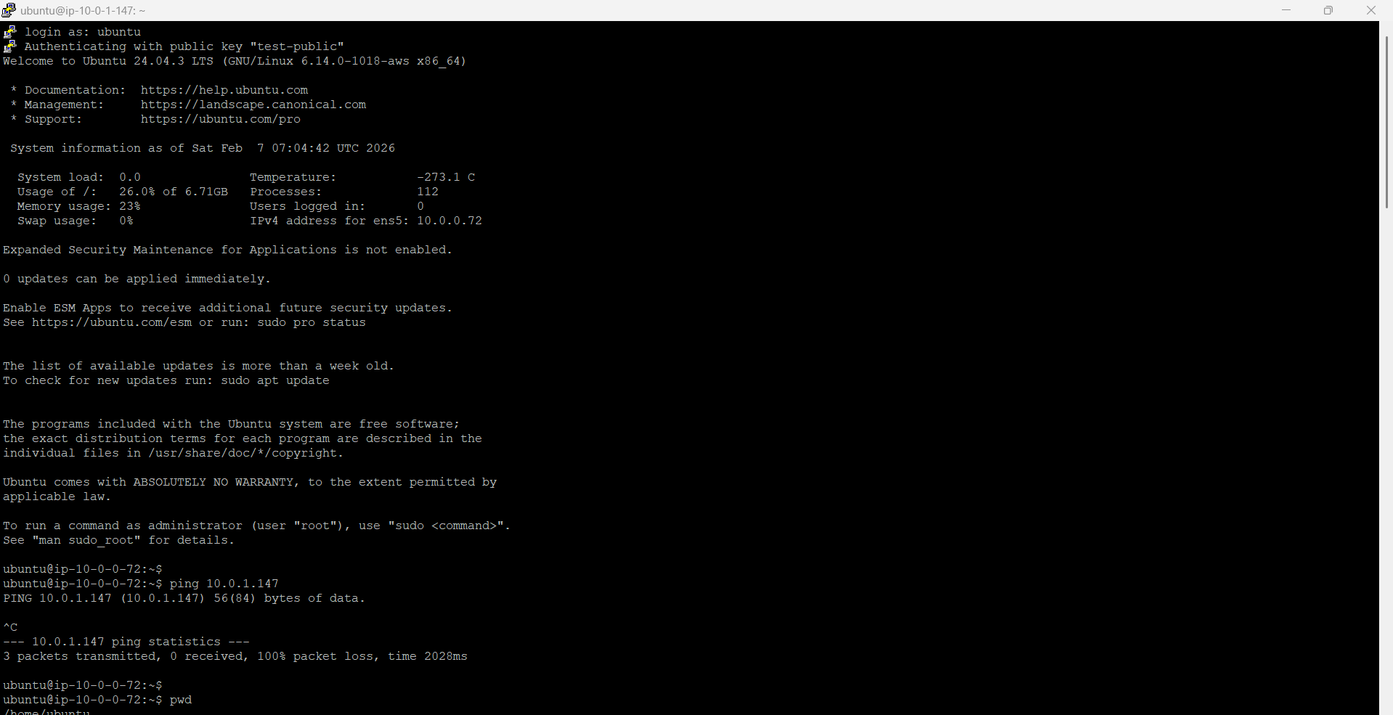
After Private subnet:
